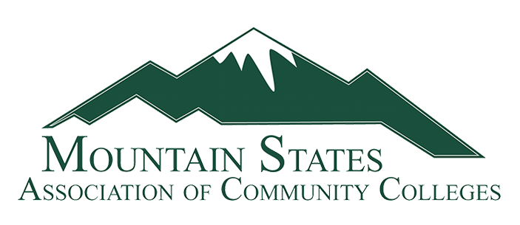

Registration

The Mountain States Association of Community Colleges Annual Conference will be held at the Snow King Resort in Jackson Hole, WY on July 6 - 8, 2023.

Please complete the registration form and return it to Candy Laney at Miles Community College, [laneyc@milescc.edu](mailto:laneyc@milescc.edu) no later than May 15, 2023.

|  |  |  |  |  |
| --- | --- | --- | --- | --- |
| Name |  | | College |  |
| Address |  | | | |
| Email |  | | Phone # |  |
| Spouses/Guest Name | |  | | |

|  |  |  |  |  |  |
| --- | --- | --- | --- | --- | --- |
|  | Yes |  | No | I will attend the Mountain States Summer Conference | |
| Any food allergies or restrictions | | | | |  |

**Thursday, July 6, 2023**

|  |  |  |  |  |
| --- | --- | --- | --- | --- |
|  | Yes |  | No | I will attend the Welcome Reception with dinner following. |
|  | Yes |  | No | My spouse/guest will be attending with me. |

**Friday, July 7, 2022**

|  |  |  |  |  |
| --- | --- | --- | --- | --- |
|  | Yes |  | No | I will attend conference sessions, including breakfast and lunch. |
|  | Yes |  | No | My spouse/guest will be attending breakfast with me. |
|  | Yes |  | No | I will be attending the group dinner |
|  | Yes |  | No | My spouse/guest will attend the dinner with me |

**Saturday, July 8, 2022**

|  |  |  |  |  |
| --- | --- | --- | --- | --- |
|  | Yes |  | No | I will attend conference sessions, including breakfast. |
|  | Yes |  | No | My spouse/guest will be attending breakfast with me. |

**Hotel reservations:**

**Candy Laney will be taking hotel reservations for the conference. Please complete the information below.**

|  |  |  |  |  |  |
| --- | --- | --- | --- | --- | --- |
| **Date of Arrival** | **Date of Departure** | **Last Name** | **First Name** | **Cell Phone Number** | **Number of Guests** |
|  |  |  |  |  |  |

**The Association will pay for rooms on July 6 and 7. Members who may want to arrive early or stay longer will be responsible for those extra days. If you would like to stay additional days prior to July 6 or after July 7, please identify this above. Extra nights are dependent upon room availability at the resort. The resort will try to accommodate all requests.**

**Transportation:**

**If you need transportation from the airport, the hotel has a complimentary hotel shuttle available, but space is extremely limited. To book either an arrival or departure pick-up, please use this link:** [*https://calendly.com/snowkingresortshuttle*](https://nam12.safelinks.protection.outlook.com/?url=https%3A%2F%2Fcalendly.com%2Fsnowkingresortshuttle&data=05%7C01%7Claneyc%40milescc.edu%7C593e091f14bf47da60d708dafe624787%7C1f87dfd664a44f2c9ae5072d8ff88531%7C0%7C0%7C638101995319771517%7CUnknown%7CTWFpbGZsb3d8eyJWIjoiMC4wLjAwMDAiLCJQIjoiV2luMzIiLCJBTiI6Ik1haWwiLCJXVCI6Mn0%3D%7C3000%7C%7C%7C&sdata=hpfwvG8QKoVbsZShg%2BtBrWCAjzFGO6F9jx%2FCeWBiUXU%3D&reserved=0)*.* **When scheduling, you must register each member of your party individually using the link.**

**The next best option recommended by the hotel is the Snake River Taxi. They can be contacted at** [**snakerivertaxi@yahoo.com**](mailto:snakerivertaxi@yahoo.com)**.**

**Please call Candy Laney if you have questions, at 406-874-6165.**