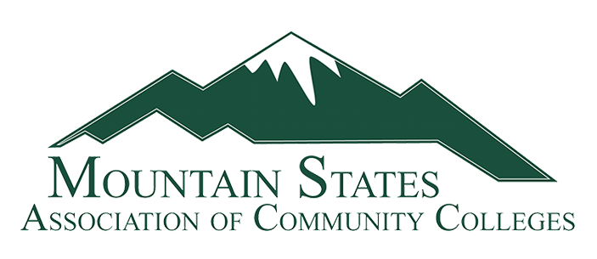

Registration
The Mountain States Association of Community Colleges Annual Conference will be held at the Flathead Valley Community College in Kalispell, MT on July 7 - 9, 2024.
Please complete the registration form and return it to Candy Laney at Miles Community College, laneyc@milescc.edu no later than April 15, 2024.
Name |  |  | College
Address
Email |  |  | Phone #
Spouses/Guest Name

 | Yes |  | No | I will attend the Mountain States Summer Conference
Any food allergies or restrictions

Sunday, July 7, 2024
 | Yes |  | No | I will attend the Welcome Reception with dinner following.
 | Yes |  | No | My spouse/guest will be attending with me.

Monday, July 8, 2024
 | Yes |  | No | I will attend conference sessions, including lunch.
 | Yes |  | No | I will attend conference sessions, but will not be attending lunch.
 | Yes |  | No | I will be attending the group dinner (this is a no-host dinner)
 | Yes |  | No | My spouse/guest will attend the dinner with me

Tuesday, July 9, 2024
 | Yes |  | No | I will attend conference sessions and would like a box lunch.
 | Yes |  | No | I will attend conference sessions and do not want a box lunch.

Hotel reservations:
Candy Laney will be taking hotel reservations for the conference. Please complete the information below.
Date of Arrival | Date of Departure | Last Name | First Name | Cell Phone Number | Number of Guests
The Association will pay for rooms on July 7 and 8. Members who may want to arrive early or stay longer will be responsible for those extra days. If you would like to stay additional days prior to July 7 or after July 8, please identify this above. Extra nights are dependent upon room availability at the hotel. The hotel will try to accommodate all requests but rooms will not be held for dates outside the conference dates. If you are looking at staying prior to or after the conference dates, contact me with those dates as soon as possible.
Transportation:
The hotel does not have a hotel shuttle available. If you need transportation from and/or to the airport, here is a link to the ground travel at the Glacier Park International Airport.
https://iflyglacier.com/ground/

Please call Candy Laney if you have questions, at 406-874-6165.

